(43) All My Loving

[Dm] [G7]

[C] . . Close your [Dm] eyes and I'll
[G7] kiss you To- [C] -morrow I'll [Am] miss you. Re-
[F] -member I'll [Dm] always be [Bb] true . . .
[G7] . . And then [Dm] while I'm a- [G7] -way I'll write
[C] home every [Am] day . And I'll
[F] send all my [G7] loving to [C] you . . .

[C] . . I'll pre [Dm] tend that I'm
[G7] kissing The [C] lips I am [Am] missing And
[F] hope that my [Dm] dreams will come [Bb] true . . .
[G7] . . And then [Dm] while I'm a- [G7] -way I'll write
[C] home every [Am] day . And I'll
[F] send all my [G7] loving to [C] you . . .

[C] . . All my [Am] loving . . . [AmM7] I will send to [C] you . .
[C] . . All my [Am] loving . . . [AmM7] darling I'll be [C] true . .

[C] . . Close your [Dm] eyes and I'll
[G7] kiss you To- [C] -morrow I'll [Am] miss you. Re-
[F] -member I'll [Dm] always be [Bb] true . . .
[G7] . . And then [Dm] while I'm a- [G7] -way I'll write
[C] home every [Am] day . And I'll
[F] send all my [G7] loving to [C] you . . .

[C] . . All my [Am] loving . . . [AmM7] I will send to [C] you . . .
[C] . . All my [Am] loving . . . [AmM7] darling I'll be [C] true . . .

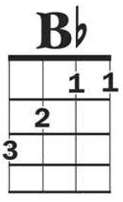
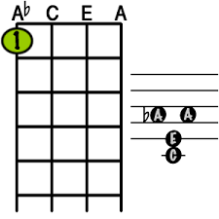
[C] . . All my [Am] loving . . . [AmM7] I will send to [C] you . . .
AmM7

